Supplementary Information to LCMHCA Application Presentation

Definition of Terms:

- Candidate for Licensure Pending (CFL-P) – This is the “status” you will become once all the sections of the applications and corresponding licensure documents have been submitted to the Board and you are waiting approval – this is the “in-between stage” while the Board waits for you official graduate school transcripts and national test scores
- Conferred transcript – the transcript once your degree has been awarded and confirmed (also referred to as “After Award Degree” or “Hold for Degree” - will be the designation used when ordering official transcripts
- Official transcript – transcript that has been bought and sent by the university registrar office – ordered through your Appalnet account
- Sign Notary Affidavit – a sworn or affirmed statement made before a notary public or any public official – will get this form to be signed by a notary at a bank or credit union from the online application
- LCMHCA - Licensed Clinical Mental Health Counselor Associate – this is the level of licensure you are applying for after completing this graduate program and corresponding national exams
- Restricted license – you will have this when you are granted the LCMHCA licensure- this means you must have a Board approved supervision contract on file
- LCMHC – Licensed Clinical Mental Health Counselor – this is what you will become after completing all necessary supervised hours and completing steps to receive your full provisional license - can take 2-3 years of working with LCMHCA status
- Unrestricted license- supervision not required – this is the licensure you will have once you become a full LCMHC
- LCMHCS – Licensed Clinical Mental Health Counselor Supervisor – this is the licensure your supervisor must have to be your Board approved supervisor for your LCMHCA
- NCBLCMHC - The North Carolina Board of Licensed Clinical Mental Health Counselors - also referenced as “the Board”

LCMHCA Application Contents Overview:
- Completing and signing the official application: http://ncblpc.org/Licensure/Applying
- Necessary forms to accompany application will become available once you complete the application and submit your payment.
- Payment form: the fee is a total of $238.00
- (application is $200, background check is $38)
- Official Conferred Transcript directly from University Registrar’s office to NCBCMHC - $7.50-$8.50 per transcript (Conferred Transcript may also be referenced as ”Official Transcript,” “After Degree is Awarded,” or “Hold for Awarded Degree”
- Electronic Forms will become available once you complete the application
- Examination Scores from NBCC sent directly to NCBCMHC (also send conferred transcript to NBCC so they can release your scores to NCBCMHC)
- Verification of Graduate Counseling Experience Form
- (from all field experience semesters completed to date). This is now done electronically.
- Professional Disclosure Statement
- Ethics Attestation Certification & Agreement
- Jurisprudence Exam – link becomes available when you complete the application
- Life-scan & Authority for Release for Criminal Background Check form
- Application Affidavit Notary

Anticipated Timeline for graduation to LCMHCA
- Send in your completed application & additional information (see slide 24) to the NCBCMHC about 2 to 4 weeks before the deadline as stated on the NBCMHC website (http://ncblpc.org/BoardInfo/calendar)
- Background check can take 4 to 6 weeks. (Life scan)
- Transcripts can take 4 to 6 weeks for the registrar’s office to send official conferred transcripts to NCBCMHC & NBCC. Order electronic transcript at least one week before LPCA application deadline (also include an unofficial transcript in your application) - Upload the email you get as your receipt to NCBCMHC.
- After NBCC receives your official conferred transcript, they can take 4 to 6 weeks. Pro Counselor will give you the opportunity to pay for your NCE scores to be sent to NCBCMHC. However you are using the old hard form – that you completed – as a receipt so you can be a CFL-P.
- University Supervisor has electronic link to complete the Verification of Graduate Experience form
- After board meets, it can take 2 to 4 weeks to receive LCMHCA notice.
- After sending in supervisor contract, it can the take 2 to 4 weeks for supervisor to receive approval letter.

Timeline Chart Example for August 2021 Graduation:
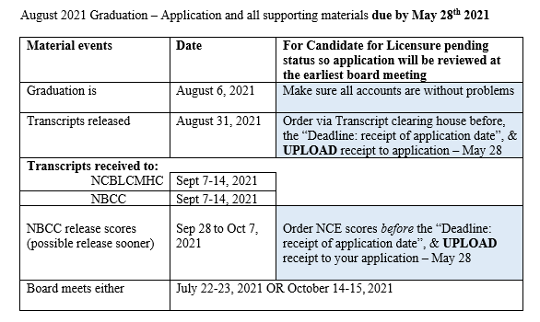
For an applicant to receive “Candidate For Licensure Pending” Status:
- The CFL-P designation allows the applicant's file to still be reviewed at the next regularly scheduled Board meeting for approval.
- License may be issued upon receipt of the missing documents (as in the transcripts and NCE score).
- The CFL-P designation is effective for a maximum of 60 days from the date of approval by the Board.
- If the missing documents are not received within the 60 days, the CFL-P designation reverts to “application in review” status.
- If the missing documents are NOT received within 60 days, the application shall be presented at the next scheduled Board meeting upon receipt of missing documents. Application remain open for a two-year period then you have to reapply and pay the $238.00 again.
Contacts:
- NCBLCMHC website: https://www.ncblpc.org/
- Board’s calendar for deadlines: https://www.ncblcmhc.org/BoardInfo/Calendar
- Phone number: 844-622-3572 or 336-217-6007
- Email: LCMHCinfo@ncblpc.org
- Addresses:
General Mail – PO Box 77819 Greensboro, NC, 27417
Overnight mail/special deliveries – 7D Terrace Way, Greensboro NC, 27403
Other Information:
- Information about ordering transcripts: https://registrar.appstate.edu/students/ordering-transcript
- Clinical Field Experience website with licensure information: https://cmhc.appstate.edu/clinical-field-experience/licensure-resources

