How to order transcripts from National Clearninghouse to send to NCBLCMHC for application:
- Go to Appalnet account
- Select “Student” tab, then select “Student Records”
- Select “Official Transcript Request” which will take you to National Clearninghouse Website
- “Order a transcript”
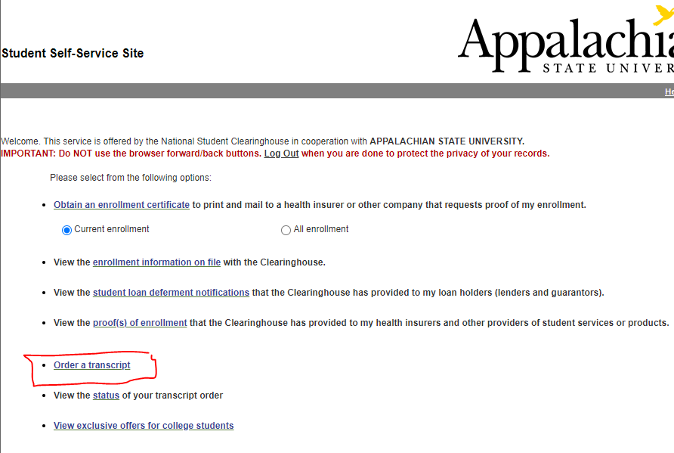
- Follow on screen directions by selecting green “Order Transcripts” button at the bottom of the next page
- Enter personal information
- Enter contact information
- When prompted to “Select Transcript and Delivery Details” select the option “Education Organization, Application Service, and Scholarship” for Recipient:
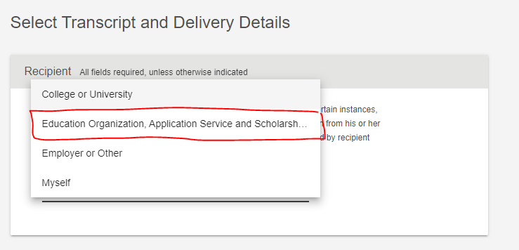
- When prompted to select organization, scroll to the bottom and select “Not in List,” then put in “NC Board of Licensed Clinical Mental Health Counselors” in blank space:
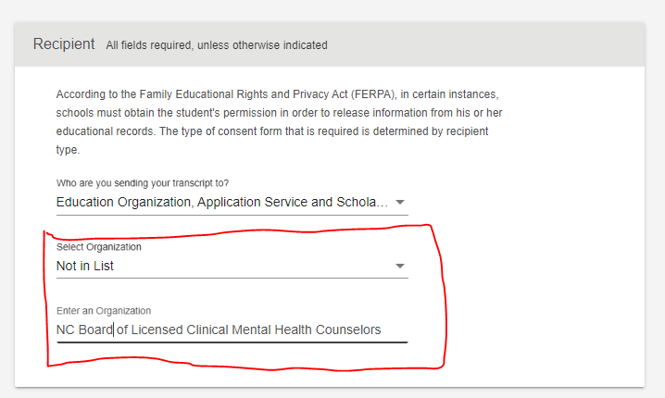
- Select the following options using the drop-down arrows on this page:
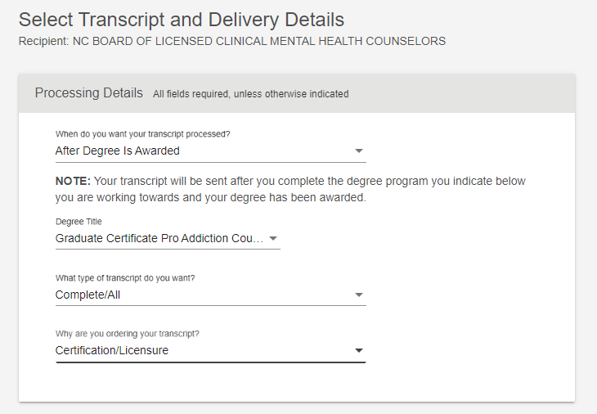
- Select the following for delivery method:
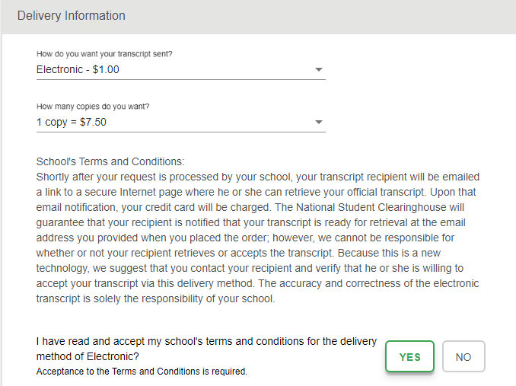
- Then this should be listed at the bottom of the page:
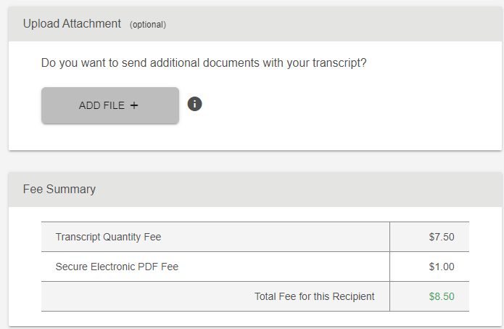
- Then provide delivery contact information (from Board website FOUND HERE):
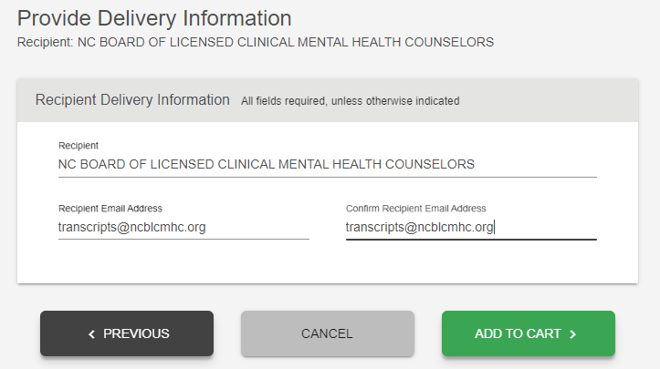
- Select “Add to Cart”
- Final page before placing order will then look like this:
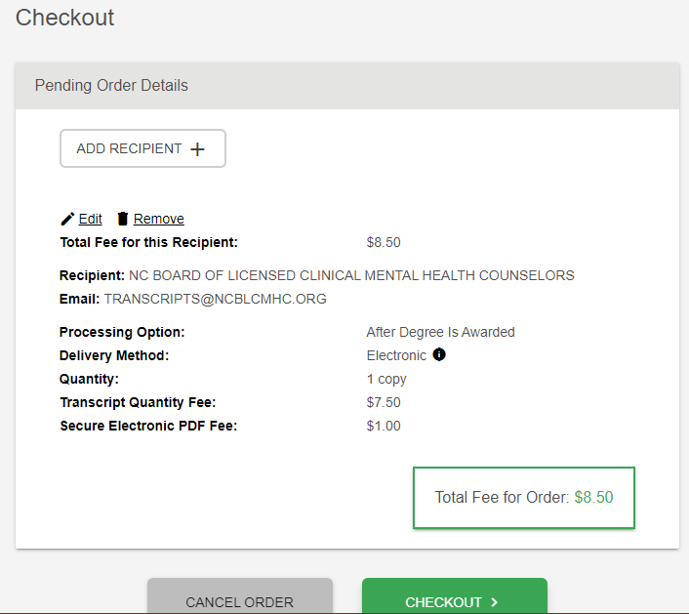
- After completing order, remember to save the receipt of the order and use that for your application

