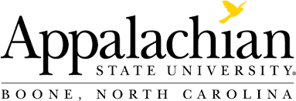

Counselor Education Programs
2020-2021 Program Evaluation
Vital Statistics Report
The Council for Accreditation of Counseling and Related Educational Programs (CACREP) requires that programs make certain information publicly available each year.

CMHC |  | PSC
Currently enrolled first-year students | 23 | 14
Currently enrolled second-year students | 19 | 13
Currently enrolled third-year students | 8 | 1
Graduates in 2020-2021 | 18 | 14
Program completion rate | 94% | 100%
Employment rate | 100% | 100%
National Counselor Examination Pass | 100% | 100%
Professional School Counselor Praxis Pass | N/A | 100%

- Reports generated for Fall 2020, Spring 2021, Summer 2021
- CMHC = MA in Clinical Mental Health Counseling, PSC = MA in School Counseling completion rate computed on rolling basis and indicates proportion of students who complete degree requirements within expected time to degree (2-3 years for full-time, 3-4 years for part-time) Employment rate indicates the proportion of students who desired employment who were employed or engaged in full-time.

